**Title: XYZ Utility Company’s Account Management Project**

**Table of Contents**

|  |  |  |
| --- | --- | --- |
| **S. No** | **Title Name** | **Page No** |
| 1. | Database Modelling (ERD Diagram) | 3 |
| 2. | Drop Statements (Tables & Sequences) | 4 |
| 3. | Create Statements (Tables & Sequences) | 4 |
| 4. | Selections & Insertions | 4 |
| 5. | Procedures & Functions (Feature 1 – Feature 15) | 4 |
| 6. | Execute Statements | 4 |

1. **Database Modelling**

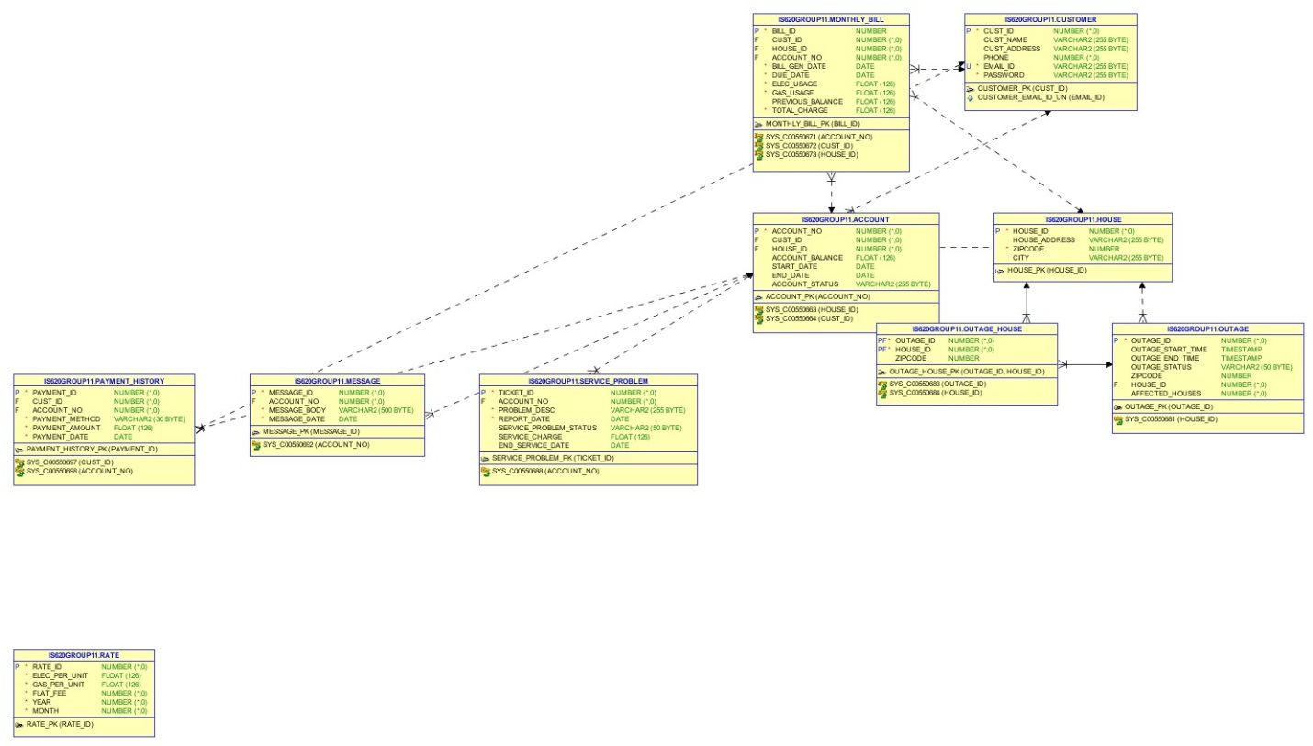

**2. Drop Statements (Tables & Sequences)**



**3. Create Statements (Tables & Sequences)**



**4. Selection & Insertion Statements**



**5. Procedures & Functions**



**6. Execute Statements**

